Java question

Public static void main(String [] args)

From anywhere jvm has to call this main methoed so it has to public

Without existing object also JVM has to call this method so this has to be static

And it;s not related to any object

JVM wont need anything from the main method

Why main()? – this is name which is configured inside the JVM

Args[] is command line arguments

When you change any syntax for main metheod then nosuchmethod error :main exception

Sysntax that are allowed to change:

Order of modifier are not IMP

For example it can also be static public void main(String [] args)

Main(String args[]) is also excpted

Main(String []prasanna) is also expected

Strange main method

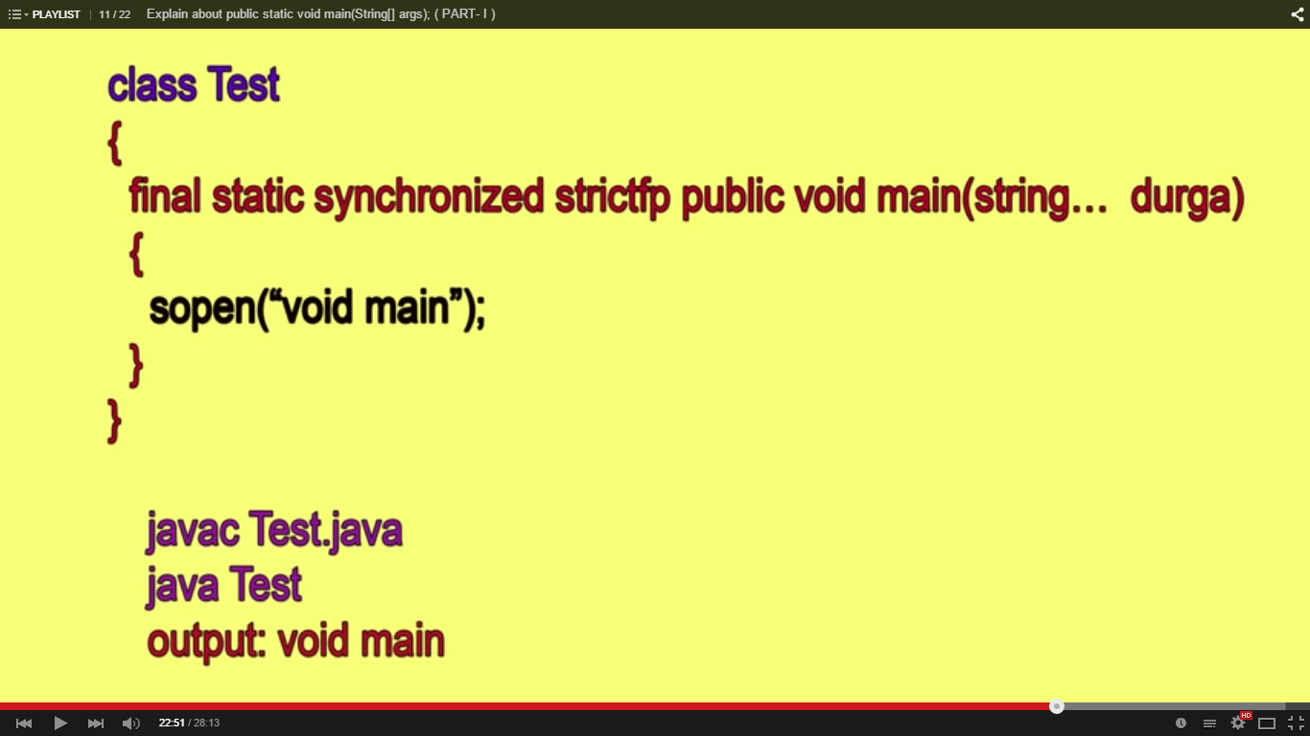

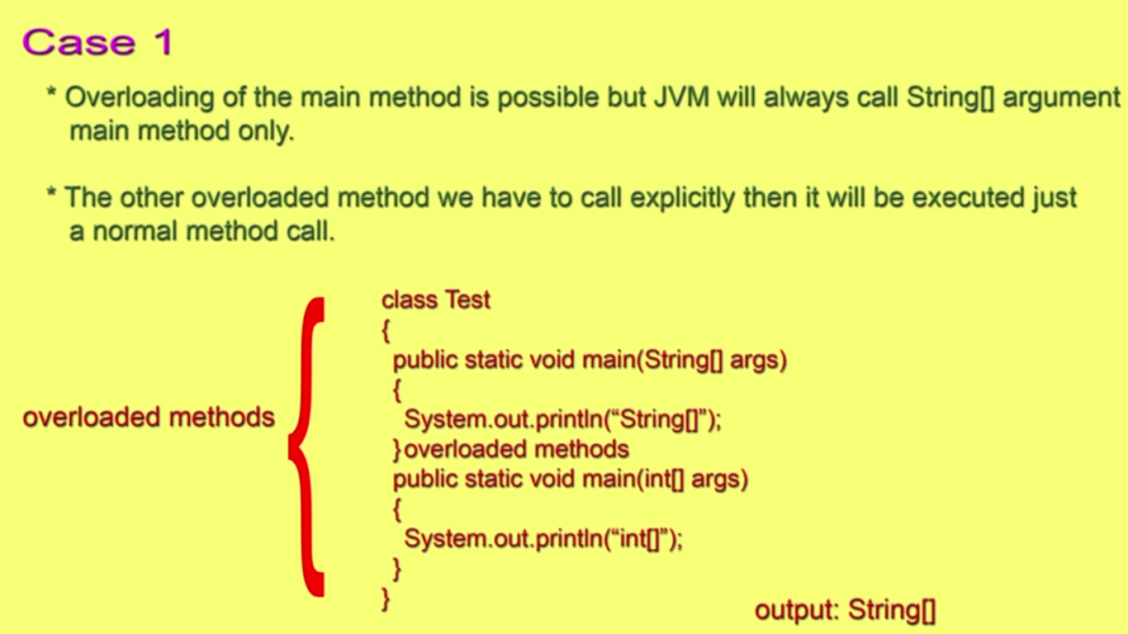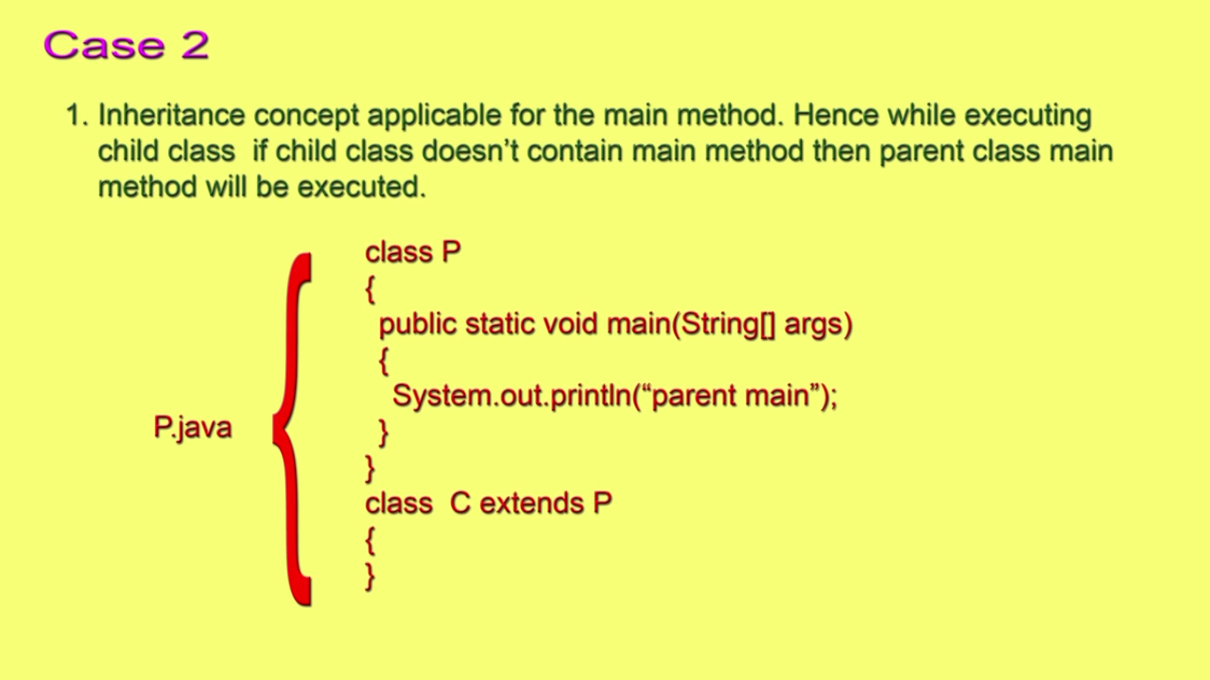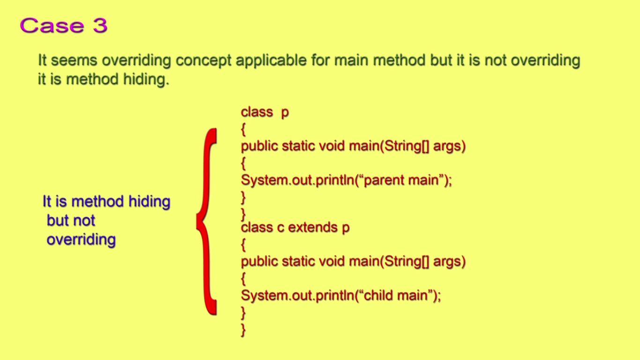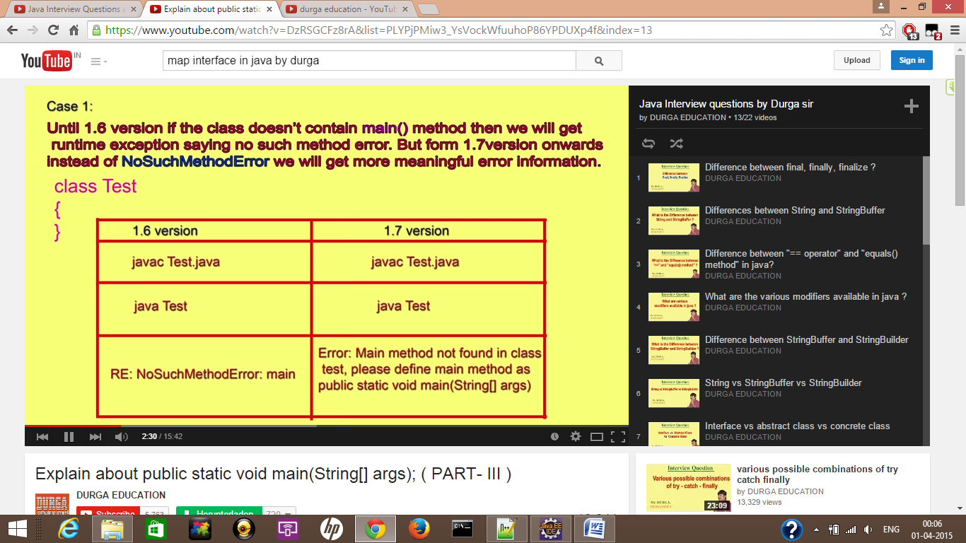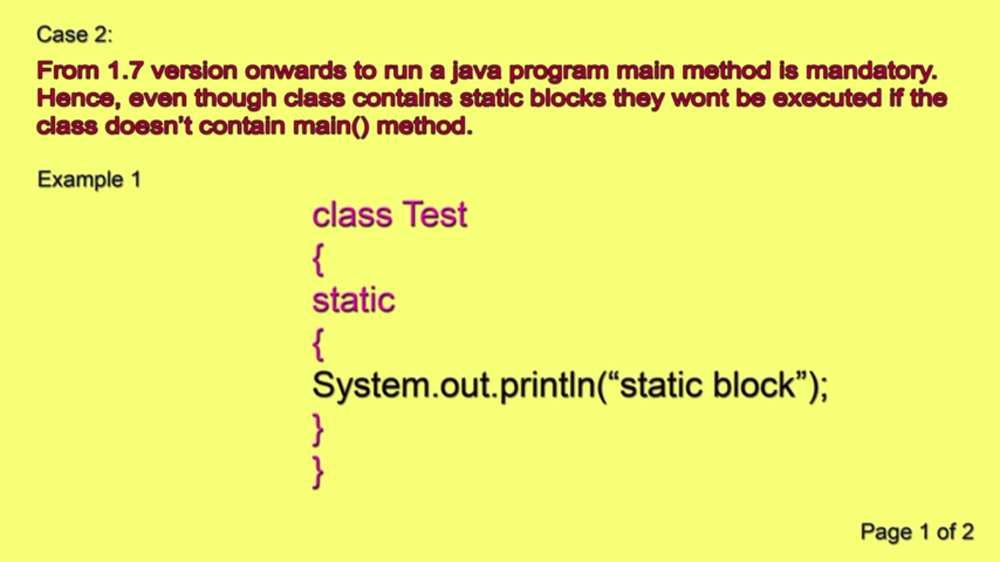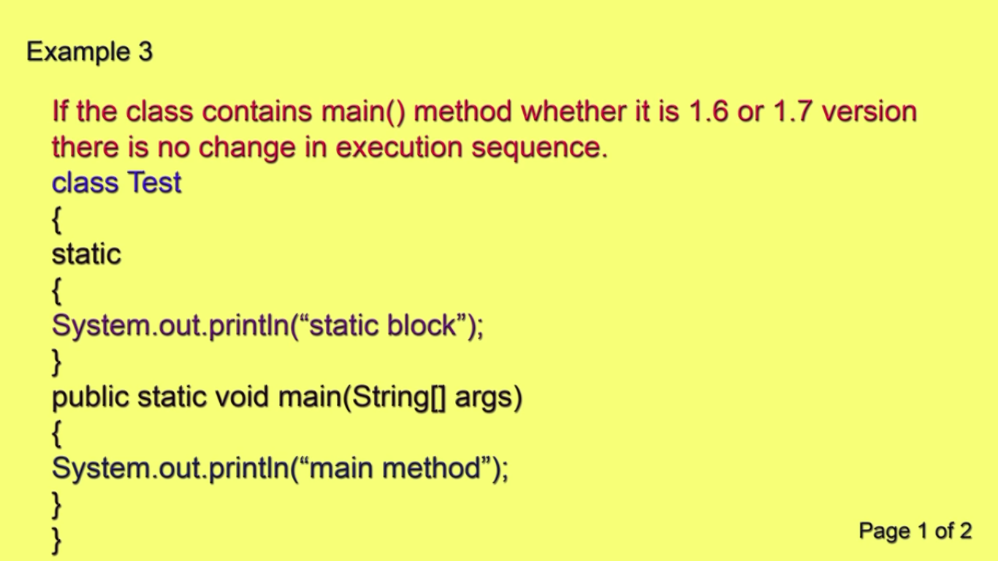

Method over loading and over riding

